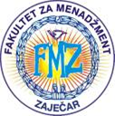 | 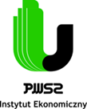 |  | 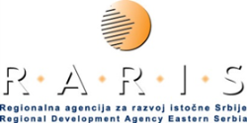 | 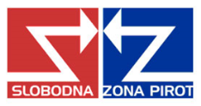

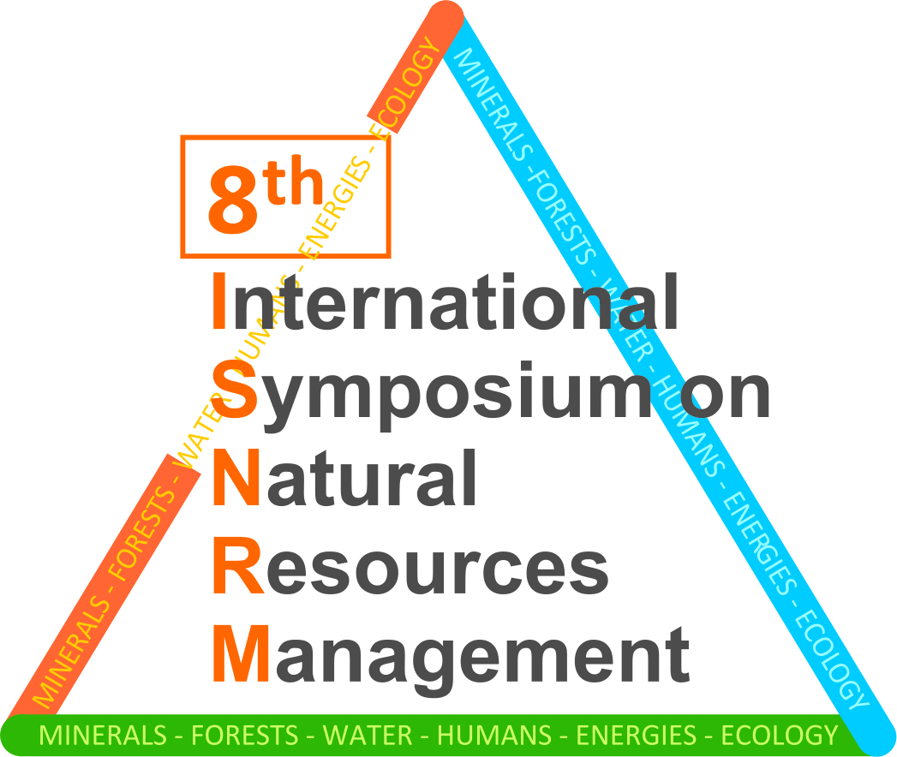
8th International Symposium
on Natural Resources Management
May 19, 2018
FACULTY OF MANAGEMENT ZAJEČAR
REPUBLIC OF SERBIA
www.fmz.edu.rs
simpozijum@fmz.edu.rs

REGISTRATION FORM

TITLE OF THE PAPER

Autor’s Name∗
Affiliation
Address

Autor’s Name
Affiliation
Address

Autor’s Name
Affiliation
Address

ABSTRACT: (not more than 100 words)

KEY WORDS: (not more than 6 words)

PAPER WITH PARTICIPATION

PAPER WITHOUT PARTICIPATION

 e-mail address of the correspondent author

